**SUBJECT: MATHEMATICS**

**TIME ALLOWED: 120MINUTES**



**Roseville Secondary School, Enugu.**

**ENTRANCE EXAMINATION 2021/2022 SESSION**

**INSTRUCTIONS**

1. This paper consists of two sections: A - Mathematics, and B- Quantitative Reasoning.
2. Attempt all questions by shading the correct option from the list of options lettered A - E on the answer sheet provided with a pencil.
3. Do not shade more than one option for each question.
4. Clearly write your examination number and date of birth on your question paper using a pen.
5. Use this paper for your rough work.
6. The use of calculators or any form of smart gadgets and wristwatches attracts outright DISQUALIFICATION.
7. Submit all question papers alongside your answer sheet.

|  |
| --- |
| **EXAMINATION NUMBER** ------------------------------------------------------------------------  **DATE:** -------------------------------------------------------------------------------------------------------------  **DATE OF BIRTH:** ------------------------------------------------------------------------------------------ |

**SECTION A: MATHEMATICS**

1. Write in words 5 000 003
2. Fifty-three
3. Five billion and three
4. Five thousand and three
5. Five million and three
6. Five and three
7. Solve MMXXVII – MCMXCII
8. LV
9. XLV
10. XXXV
11. XXV
12. VL
13. What is the greatest prime factor of 34 and 204?
14. 2
15. 4
16. 5
17. 13
18. 17
19. In the sequence: 1, 3, 7, 13, 21, …, what number should come next?
20. 30
21. 31
22. 32
23. 33
24. 35
25. Find the L.C.M. of 15 and 45

A. 15

B. 30

C. 45

D. 60

E. 75

1. The number which is 3 greater than *n* is
2. n + 3
3. 3n
4. n – 3
5. n
6. Laraba has *x* naira. Kunle has 15 naira less than Laraba. Together, the number of naira they have is
7. x – 15
8. 2x
9. 2x – 15
10. 2x + 15
11. 15
12. The next term in the sequence 1, 4, 10,

19, 31, is

1. 32
2. 34
3. 43
4. 46
5. 50
6. A triangle whose angles are 1100 , 500

and 200 is a/an example ------ triangle.

1. Acute-angled
2. Equilateral
3. Isosceles
4. Obtuse-angled
5. Right-angled
6. A pair of angles whose sum is equal to

1800 are ---

1. Acute
2. Complementary
3. Obtuse
4. Reflex
5. Supplementary
6. If x0 + 520 = 900, then x is an/a …… angle.
7. acute
8. obtuse
9. right
10. straight
11. Reflex
12. Three lines meet at a point. If the sum of two of the angles formed is 1630, the other angle is:
13. 170
14. 730
15. 1630
16. 1970
17. 3430
18. A regular triangle is equilateral and a

regular quadrilateral is a

1. Trapezium
2. Square
3. Rectangle
4. Parallelogram
5. Circle
6. Which of the following is divisible by 6?
7. 281
8. 323
9. 416
10. 510
11. 609
12. Which of these statements is/are true?
13. 1089 is divisible by 6.
14. 1089 is divisible by 9.
15. 1089 is a perfect square.
16. a only
17. b only
18. c only
19. a and b only
20. b and c only.
21. Solve for *m* in the equation 16 – m = 9.
22. 25
23. 15
24. 7
25. 27
26. – 25
27. Given that a2 = 1 x 4 x 9, find a.
28. 1
29. 4
30. 5
31. 6
32. 7
33. What is p2q - q2p, if p = 3 and q = 1?

A. 12

B. -12

C. 6

D. -6

E. 0

1. Simplify 6x – 3y – (3x – 7y).
2. 3x – 10y
3. 9x + 4y
4. 3x + 10y
5. 9x – 4y
6. 3x + 4y
7. If 2x + 1 = 15, then x =
8. 7
9. 8
10. 12
11. 14
12. 16
13. If a+4 = b+6, then
14. a < b
15. a = b
16. a > b
17. a = 2b
18. a < 2b
19. If x : 6 = 15 : 30, find the value of x.
20. 2
21. 3
22. 6
23. 12
24. 18
25. If x + y = t, then ‘t’ is the
26. difference between x and y
27. product of x and y
28. reciprocal of x and y
29. quotient of x and y
30. sum of x and y.
31. If m/4 = 100, what is the value of m/2?
32. 100
33. 200
34. 300
35. 400
36. 500
37. Which of the following number is NOT a factor of 36?
38. 1
39. 2
40. 3
41. 4
42. 5
43. What is the sum of five consecutive integers if the middle one is 14?
44. 40
45. 50
46. 60
47. 70
48. 80
49. Find the value of (101)2 in base two.
50. 1 001
51. 10 001
52. 10 111
53. 11 001
54. 11 011
55. Subtract 18 from the product of 20 and 3.
56. 1
57. 5
58. 6
59. 42
60. 78
61. A sales girl earns ₦3000 per week. Each week she spends ~~₦~~3x on food and ₦2x on rent and saves the rest. How much does she save in a week?
62. ~~₦~~(3000 – 3x)
63. ~~₦~~(3000 – 2x)
64. ~~₦~~(3000 – 5x)
65. ₦(1500 – 5x)
66. ~~₦~~(2000 – 6x)
67. 250g of sugar costs ~~₦~~150 at shop X. 100g of sugar costs ~~₦~~95 at shop Y. The difference in cost per kg is
68. ~~₦~~55
69. ~~₦~~220
70. ~~₦~~250
71. ~~₦~~260
72. ~~₦~~350
73. A woman bought 10 crates of eggs from

the market. On getting home, she realized

that 15 eggs were broken. What

percentage of the eggs was broken? (Take

one crate to contain 30 eggs).

1. 50%
2. 15%
3. 12 ½ %
4. 10%
5. 5%
6. A farmer bought some compact discs for ₦3500 per pack. She sold them at a profit of 12%. What is the selling price per pack?
7. ₦3000
8. ₦3080
9. ₦3670
10. ₦3920
11. ₦4100
12. Esther is three times as old as her sister Janet. If the sum of their ages is 20 years, find the difference of their ages.
13. 3 years
14. 8 years
15. 10 years
16. 12 years
17. 16 years
18. A man spent ¼ of his pay on food and 1/5

on meat. What fraction of his pay is left?

1. 7/20
2. 8/20
3. 9/20
4. 11/20
5. 11/24
6. If 20% of a number is 20, find the

number.

1. 120
2. 100
3. 80
4. 60
5. 40
6. If 20% of x is 8, what is x% of 120?
7. 18
8. 20
9. 25
10. 40
11. 48
12. If two-thirds of a number is 18, find the number.
13. 9
14. 18
15. 27
16. 30
17. 36
18. The closest estimate of 58.7 x 10.03 is
19. 300
20. 400
21. 500
22. 600
23. 700
24. 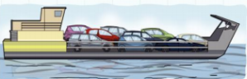A ferry can carry 9 cars. How many ferries do you need to take 116 cars across the river?
25. 11
26. 12
27. 13
28. 15
29. 17

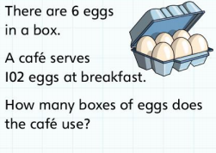

1. 11
2. 13
3. 14
4. 15
5. 17
6. The reciprocal of 4/3 is
7. 3
8. 4
9. 11/3
10. 3/4
11. 12
12. The square root of 136 is between
13. 11 and 12
14. 12 and 13
15. 100 and 130
16. 120 and 130
17. 130 and 140
18. What number is the cube of 3 divided by 3?
19. 3
20. 6
21. 9
22. 12
23. 27
24. The number of eighths in 7/8 is
25. 31/2
26. 7
27. 8
28. 56
29. 11/7
30. 1.6 kilometers equals approximately 1mile. If a charity walkathon is 18kilometers, about how many miles is it?
31. 10
32. 11
33. 12
34. 14
35. 16
36. A dice was thrown 12 times and the scores were: 2, 1, 6, 3, 6, 2, 4, 3, 5, 5, 6, 5. What is the modal score?
37. 1
38. 2
39. 6
40. 5
41. 4

**Use the information below to answer questions 47 - 50.**

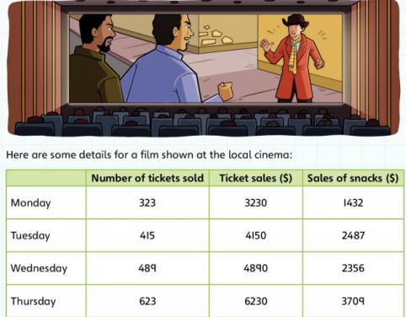

1. How many tickets were sold altogether on Monday and Wednesday?
2. 812
3. 738
4. 638
5. 946
6. 1112
7. Which day were the most tickets sold?
8. Monday
9. Tuesday
10. Wednesday
11. Thursday
12. Friday
13. How much does a ticket cost?
14. ＄5
15. ＄10
16. ＄15
17. ＄50
18. ＄100
19. How much more money was spent on snacks on Thursday than on Tuesday?
20. ＄1353
21. ＄2277
22. ＄131
23. ＄1222
24. ＄1055
25. The diagonals of one of the following always cross at right angles. Which one?
26. Rectangle
27. Parallelogram
28. Square
29. Trapezium
30. Regular pentagon
31. Which one of the following has no lines of symmetry?
32. Equilateral triangle
33. Circle
34. Regular hexagon
35. Isosceles triangle
36. Scalene triangle
37. A perimeter of a rectangle is 2.8 meters. The length of one of its sides is equal to one-seventh of the entire perimeter. Find lengths of the sides of the parallelogram.
38. 2 and 0.8
39. 2 and 0.4
40. 1 and 0.4
41. 10 and 4
42. 28 and 0
43. If the area of a square is 361 square units. What is the length of a side of the square?
44. 17 units
45. 19 units
46. 21 units
47. 11 units
48. 15 units
49. The perimeter of a rectangle is 36 cm. Find the breadth of the rectangle if its length is 22 cm?
50. 2
51. -2
52. 9
53. -4
54. -9
55. Calculate the volume of a cuboid 3cm

by 8cm by 5cm.

A. 120cm3

B. 88cm3

C. 16cm3

D. 14cm3

E. 8cm3

1. A square has the same perimeter as a 3 cm by 5cm rectangle. Which of the following is the area of the square?
2. 49cm2
3. 15cm2
4. 25cm2
5. 16cm2
6. 9cm2
7. A length of wire is given as 6.8 cm correct to 2 significant figures.
8. 6.7 cm
9. 6.74 cm
10. 6.75 cm
11. 6.8 cm
12. 6.85 cm
13. 5300 ml expressed in litres is:
14. 0.053
15. 0.53
16. 5.3
17. 53
18. 530
19. The angles between the hands of a clock at 2 o’clock is:
20. 150
21. 300
22. 480
23. 600
24. 900

**QUANTITATIVE REASONING**

1. Study the sample below and answer the question.

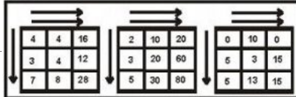

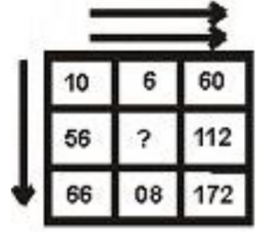

1. 80
2. 4
3. 2
4. 60
5. 56
6. Study the sample carefully and answer the question.

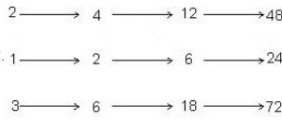



1. 1/8
2. 1/4
3. 1
4. 2
5. 3
6. Study the sample below and answer the question

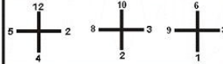

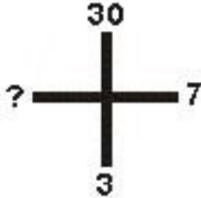

1. 10
2. 7
3. 17
4. 16
5. 14
6. Study the sample below and answer the question.

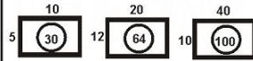

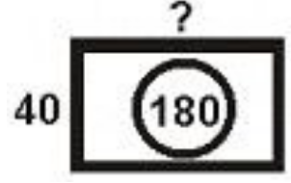

1. 220
2. 140
3. 25
4. 100
5. 50
6. Study the sample below and answer the question.

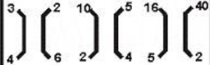

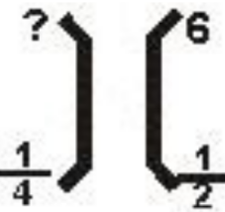

1. 24
2. 12
3. 16
4. 12
5. 2
6. Study the sample below and answer the question.



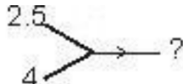

1. 1.82
2. 2.0
3. 2.25
4. 2.75
5. 2.85
6. Study the sample below and answer the question.



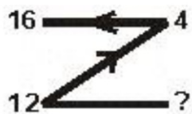

1. 12
2. 8
3. 6
4. 4
5. 2
6. Study the sample below and answer the question.



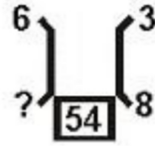

1. 37
2. 30
3. 24
4. 14
5. 5
6. Study the sample below and answer the question.

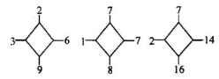

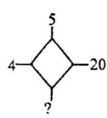

1. 20
2. 24
3. 21
4. 19
5. 25
6. Study the sample below and answer the question.

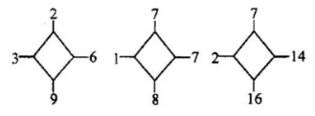

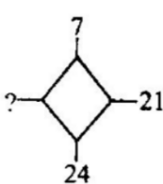

1. 7
2. 5
3. 4
4. 3
5. 2
6. Study the sample below and answer the question.

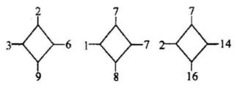

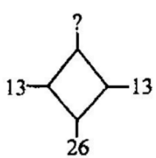

1. 5
2. 4
3. 3
4. 2
5. 1
6. Study the sample below and answer the question.

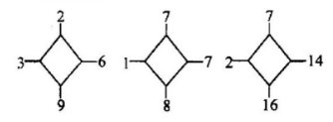

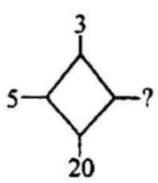

1. 25
2. 23
3. 15
4. 28
5. 60
6. Study the sample below and answer the question.

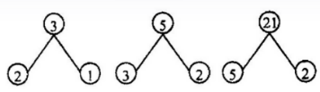

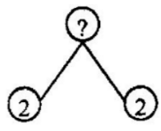

1. 6
2. 5
3. 2
4. 4
5. 0
6. Study the sample below and answer the question.

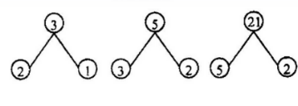

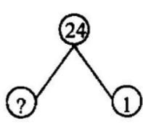

1. 5
2. 10
3. 6
4. 8
5. 12
6. Study the sample below and answer the question.

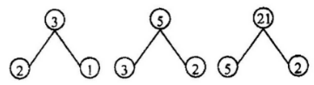

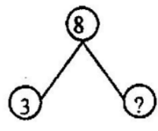

1. 3
2. 9
3. 7
4. 1
5. 0
6. Study the sample below and answer the question.

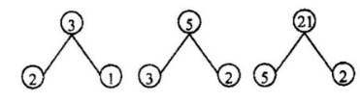

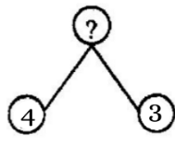

1. 1
2. 3
3. 8
4. 7
5. 11
6. Study the sample below and answer the question.

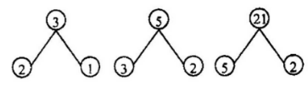

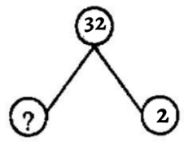

1. 6
2. 7
3. 8
4. 9
5. 10
6. Study the sample below and answer the question.

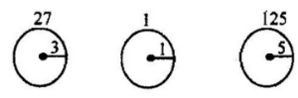

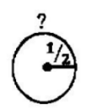

1. 1/8
2. 1/6
3. 1/4
4. 1/2
5. 1
6. Study the sample below and answer the question.

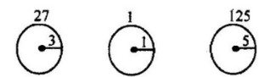

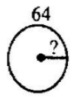

1. 2
2. 16
3. 6
4. 8
5. 4
6. Study the sample below and answer the question.

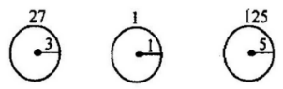

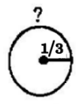

1. 1/3
2. 1/6
3. 18
4. 1/27
5. 1/30
6. Study the sample below and answer the question.

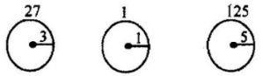

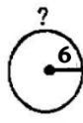

1. 6
2. 12
3. 36
4. 216
5. 309
6. Study the sample below and answer the question.

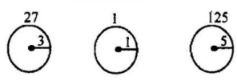

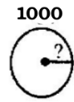

1. 10
2. 100
3. 101
4. 11
5. 110
6. Study the sample below and answer the question.

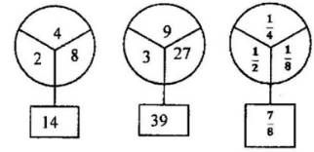

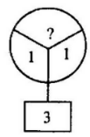

1. 5
2. 4
3. 3
4. 2
5. 1
6. Study the sample below and answer the question.

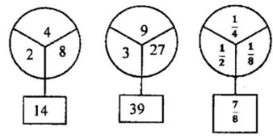

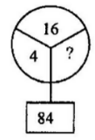

1. 20
2. 24
3. 53
4. 64
5. 81
6. Study the sample below and answer the question.

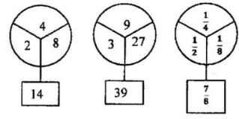

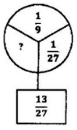

1. 2/5
2. 1/3
3. 1/4
4. 1/9
5. 3/4
6. Study the sample below and answer the question.

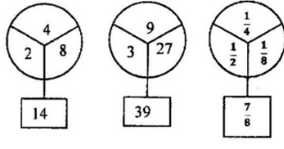

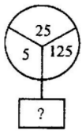

1. 155
2. 130
3. 95
4. 80
5. 99
6. Study the sample below and answer the question.

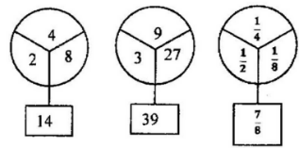

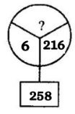

1. 6
2. 12
3. 36
4. 40
5. 50
6. Study the sample below and answer the question.

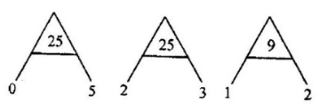

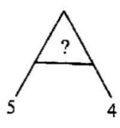

1. 9
2. 20
3. 24
4. 44
5. 81
6. Study the sample below and answer the question.

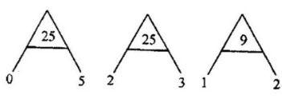

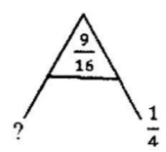

1. 1/4
2. 1/3
3. 2/3
4. 1/2
5. 3/4
6. Study the sample below and answer the question.

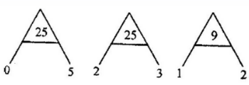

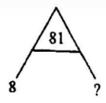

1. 1
2. 2
3. 3
4. 9
5. 10
6. Study the sample below and answer the question.

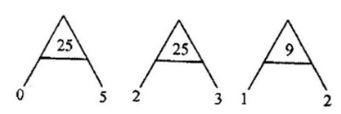

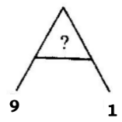

1. 10
2. 8
3. 100
4. 1000
5. 101
6. Study the sample below and answer the question.

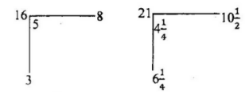

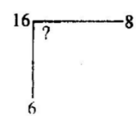

1. 2
2. 4
3. 6
4. 8
5. 10
6. Study the sample below and answer the question.

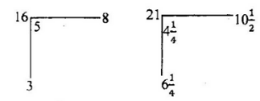

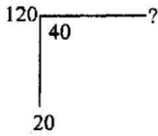

1. 40
2. 50
3. 60
4. 70
5. 90
6. Study the sample below and answer the question.

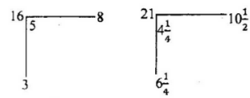

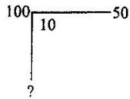

1. 40
2. 60
3. 80
4. 100
5. 120
6. Study the sample below and answer the question.

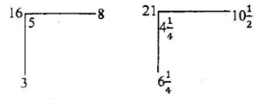

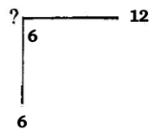

1. 36
2. 18
3. 24
4. 28
5. 30
6. Study the sample below and answer the question.

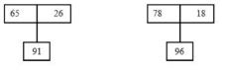

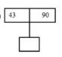

1. 133
2. 57
3. 43
4. 120
5. 70
6. Study the sample below and answer the question.



Capture

1. 100
2. 120
3. 2
4. 200
5. 110
6. Study the sample below and answer the question.



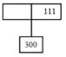

1. 179
2. 169
3. 135
4. 125
5. 101
6. Study the sample below and answer the question.



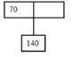

1. 20
2. 100
3. 70
4. 90
5. 130
6. Study the sample below and answer the question.



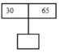

1. 95
2. 30
3. 35
4. 60
5. 105